|  |
| --- |
|  |
| E-Portfolio Documentation |
| A quick look at my projects |
|  |
| **Jared Starr** |
| **3/24/2015** |

Table of Contents

Before Death 2

About 2

How to run the game 2

Controls 2

Controller 2

Keyboard 2

Screenshots 3

Megaman V. Thornton 6

About 6

How to run the game 6

Controls 6

Screenshots 7

SpaceE 9

About 9

How to run the game 9

Contols 9

Screenshots 10

GameJam Game 12

About 12

How to run the game 12

Controls 12

Screenshots 13

Blender Works 15

Lighthouse Island 15

Little Town 16

Opening Room 17

|  |
| --- |
|  |

# Before Death

## About

Before death is the largest project I’ve ever worked on. It is a fully fleshed out 3D horror game that a team and I created for our final project in a game design course. There are two versions of the game, one version for keyboard use and another for Xbox 360/One use. Both run using the Unity 3D game engine, specifically version 4.6.2f1. The game is a prequel to one of the first games I ever made, SpaceE, which is also included in my portfolio.

## How to run the game

After downloading the folder from github, click on the version you wish to run. (Controller or Keyboard) The game should start automatically as long as you have Unity3D installed on your computer. You will have to have the folder titled “BeforeDeath(Controller Build)_Data” “BeforeDeath(Keyboard Build)_Data” or downloaded as well. Otherwise, the game will not run. After you have opened the game, select a resolution and a graphics level you wish to use, and then press play.

## Controls

### Controller

Start button – begins the game

Left Stick – forward, backward, sideways movement

Right Stick – aims the camera

A button – turns flashlight on/off (from cave onward)

RB or LB – Hold to sprint

X – hold to hide (from cave onward)

B and Y – press while the flashlight is off to recharge the battery

### Keyboard

Enter – begins the game

WASD Keys – forward, backward, sideways movement

Mouse – aims the camera

F key – turns flashlight on/off (from cave onward)

Space bar – hold to sprint

C – hold to hide (from cave onward)

Q and E – press while the flashlight is off to recharge the battery

**NOTE:** At any time in the final cave, the player can press the END key on the keyboard to completely stop the movement of the enemy. This command cannot be undone, but will allow the player to explore the cave or find their way to the end without worrying about being caught.

## Screenshots

Title Screen

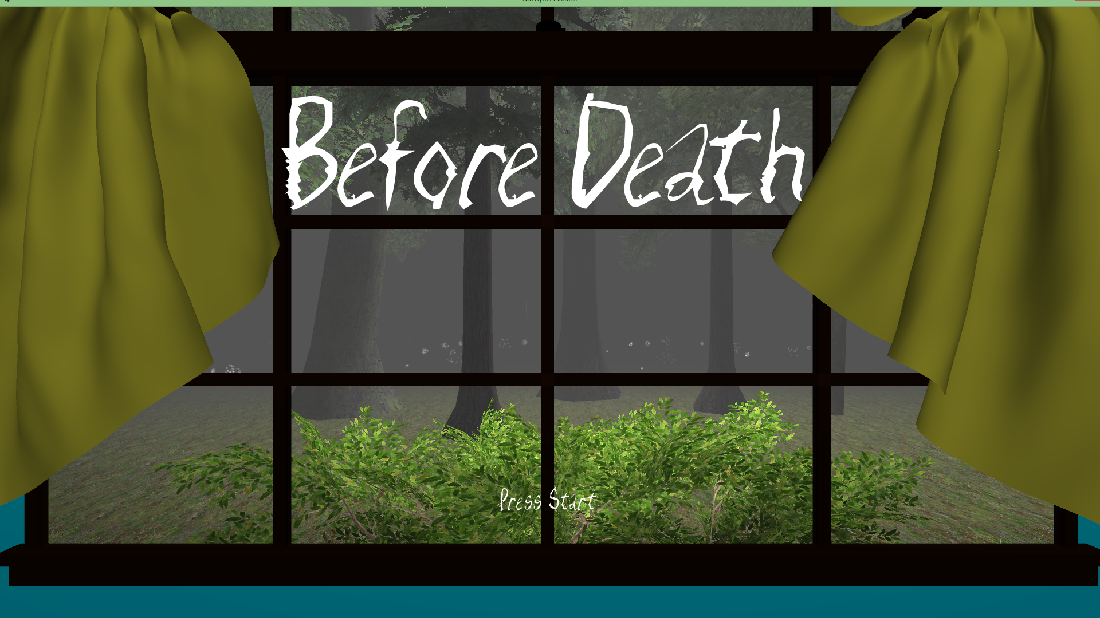

Cave Entrance

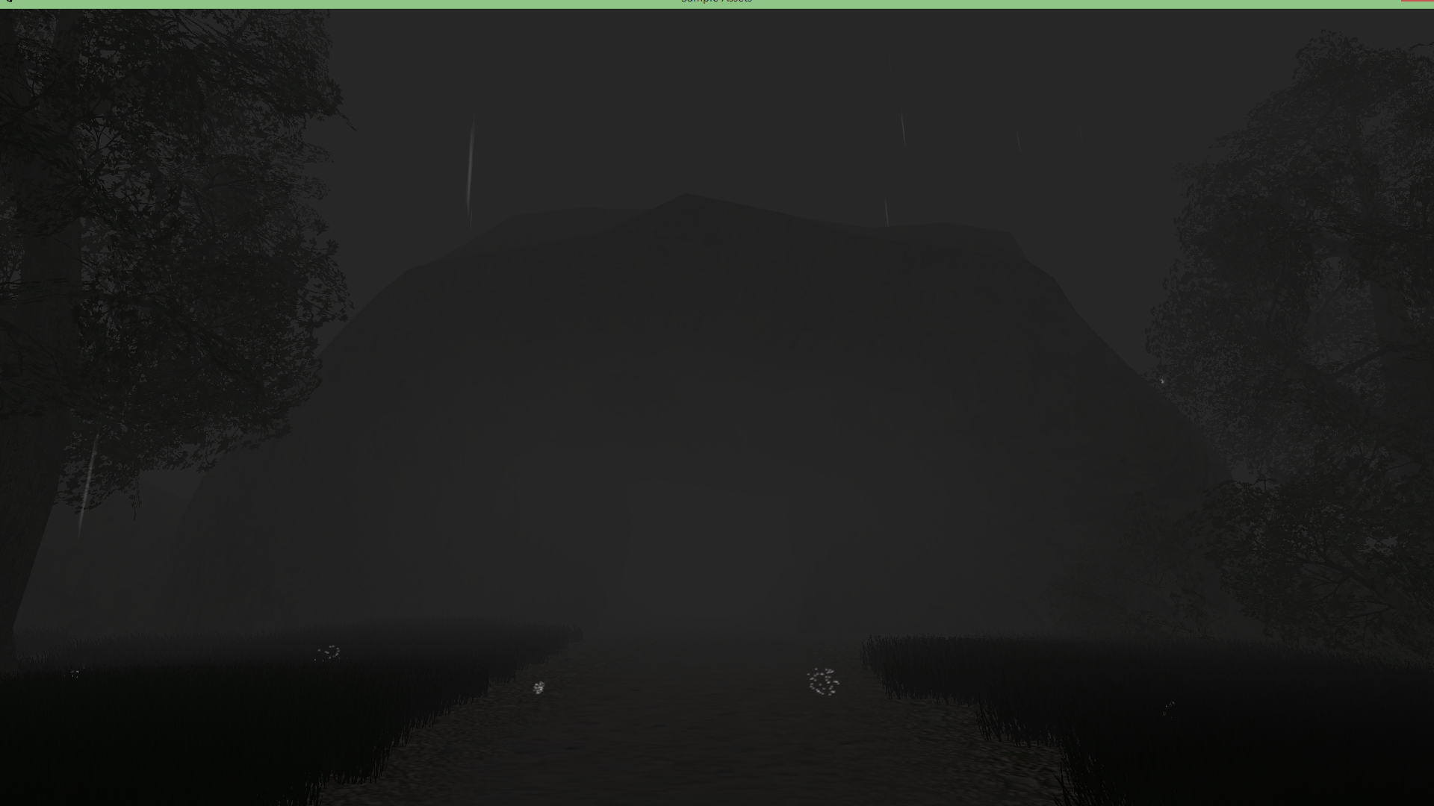

Inside the first Cave

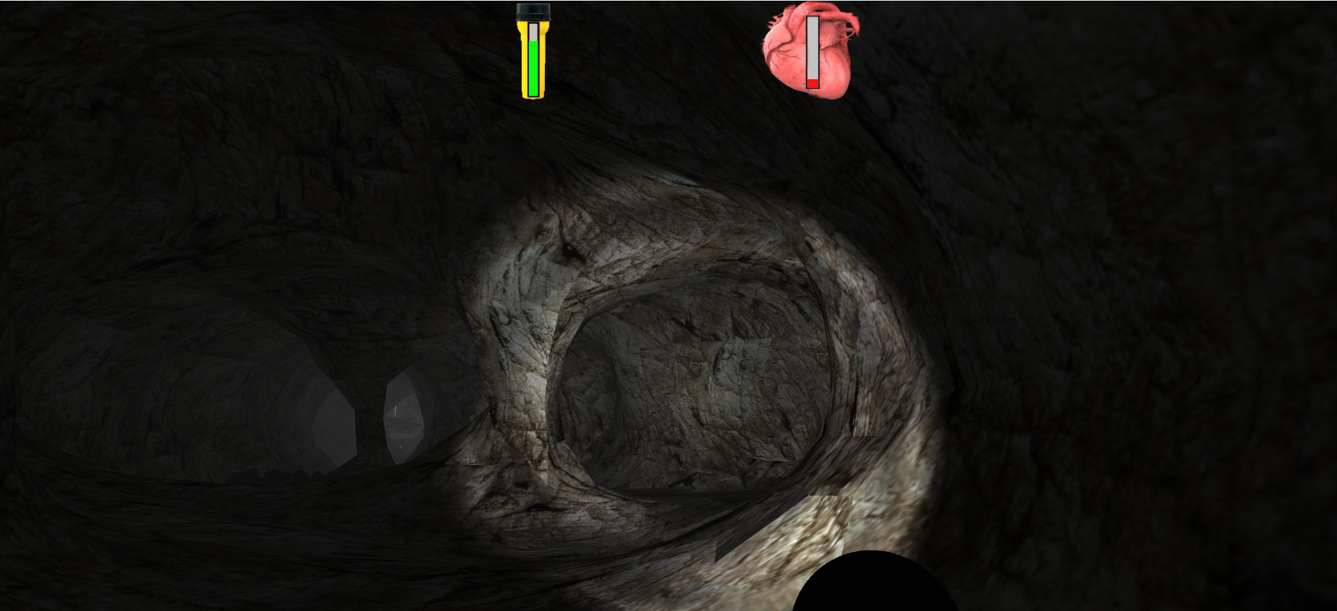

First encounter with “the creature” in the second cave

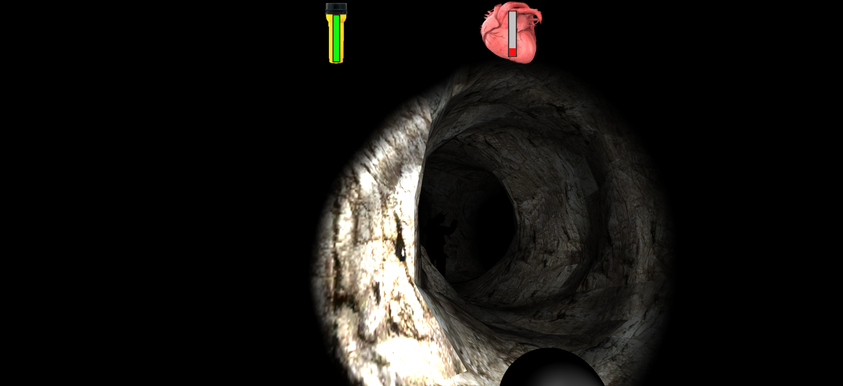

Nowhere to hide!

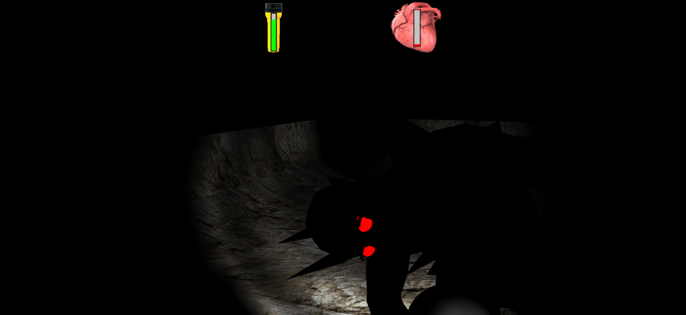

# Megaman V. Thornton

## About

Megaman V. Thornton was the first original game that I had ever worked on. As a long-time fan of the Megaman series, I thought it would be really interesting to have the iconic blue bomber battle with some of the teachers at my university. However, due to the limitations of Gamemaker at the time, I was only able to create one level and one boss, which ended up being my game design teacher, Dr. David Thornton. The game itself imitates the classic Megaman style very closely, from jump height to bullet speed. However, like the rest of the Gamemaker games in my portfolio, this game is prone to crashing. This is because Gamemaker has gone through many updates and changes since I made these games, and some of the code I wrote for them no longer works properly.

## How to run the game

To run Megaman V. Thornton, open the containing folder named “Megaman Game” and click on the GameMaker file titled “Megaman.project.” This will open the game inside of the GameMaker software. After this, press the green start arrow in the top left corner of the screen.

## Controls

Enter key – begin game

Left/right arrow keys – move left and right

Up arrow key – jump

F key – fire

D key – change abilities

## Screenshots

The Title Screen

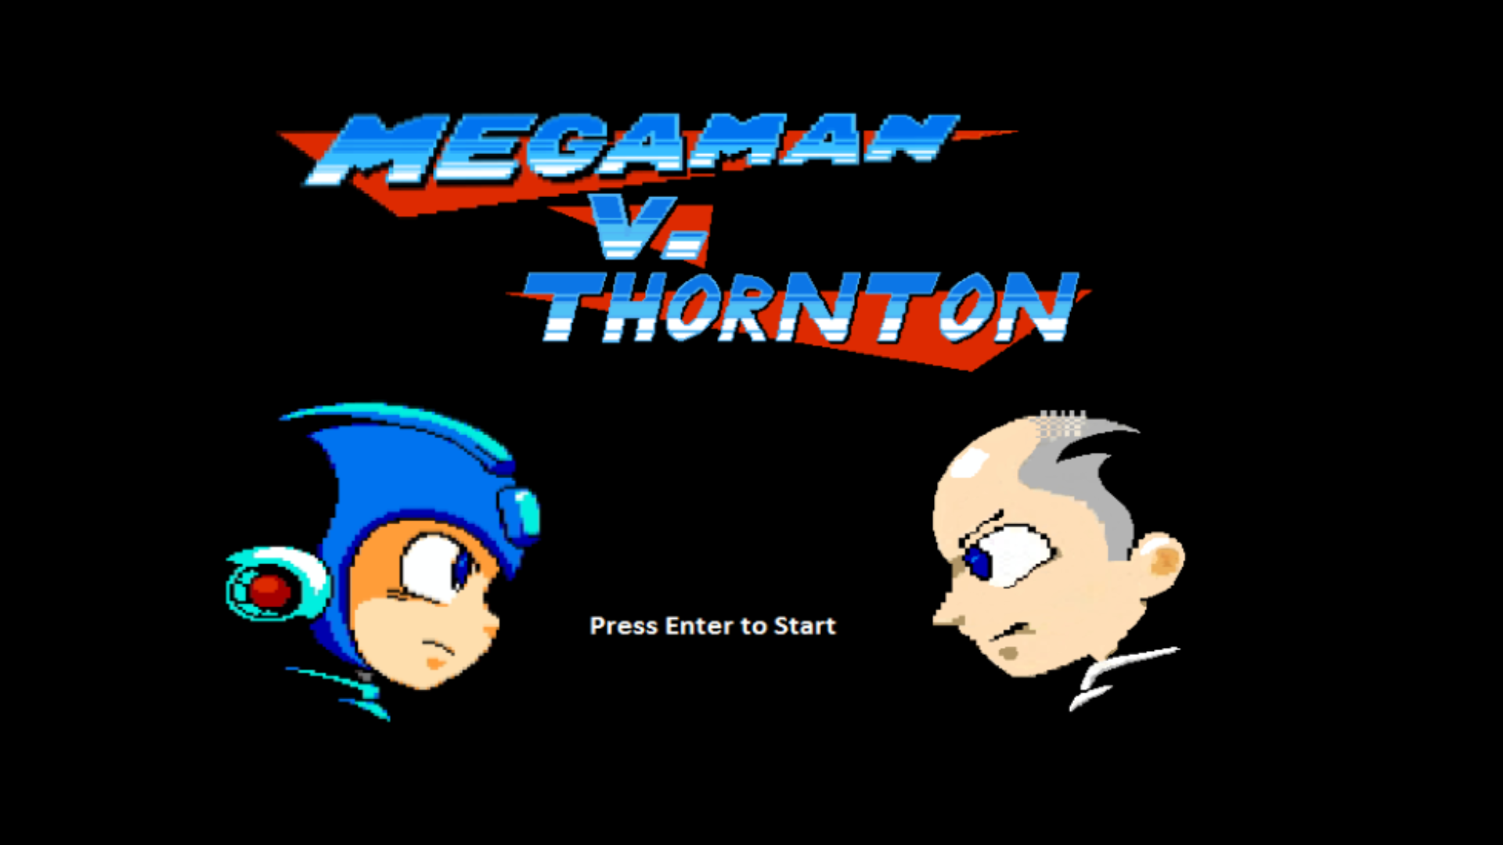

Megaman uses a health-stealing attack on a JSU themed enemy

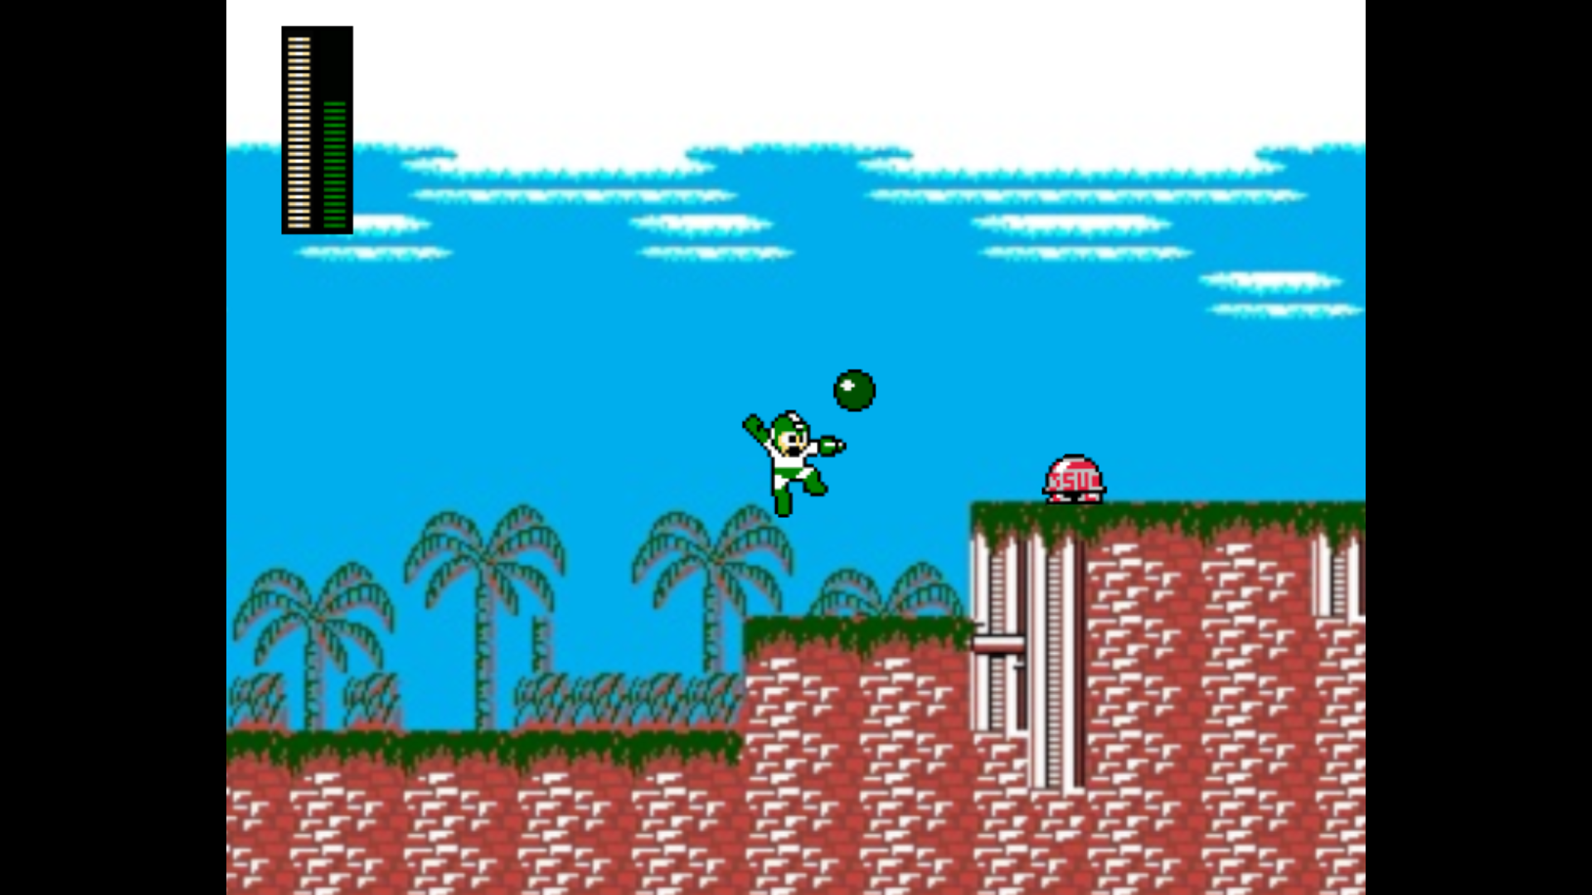

Megaman uses a piercing fire blast on approaching enemies

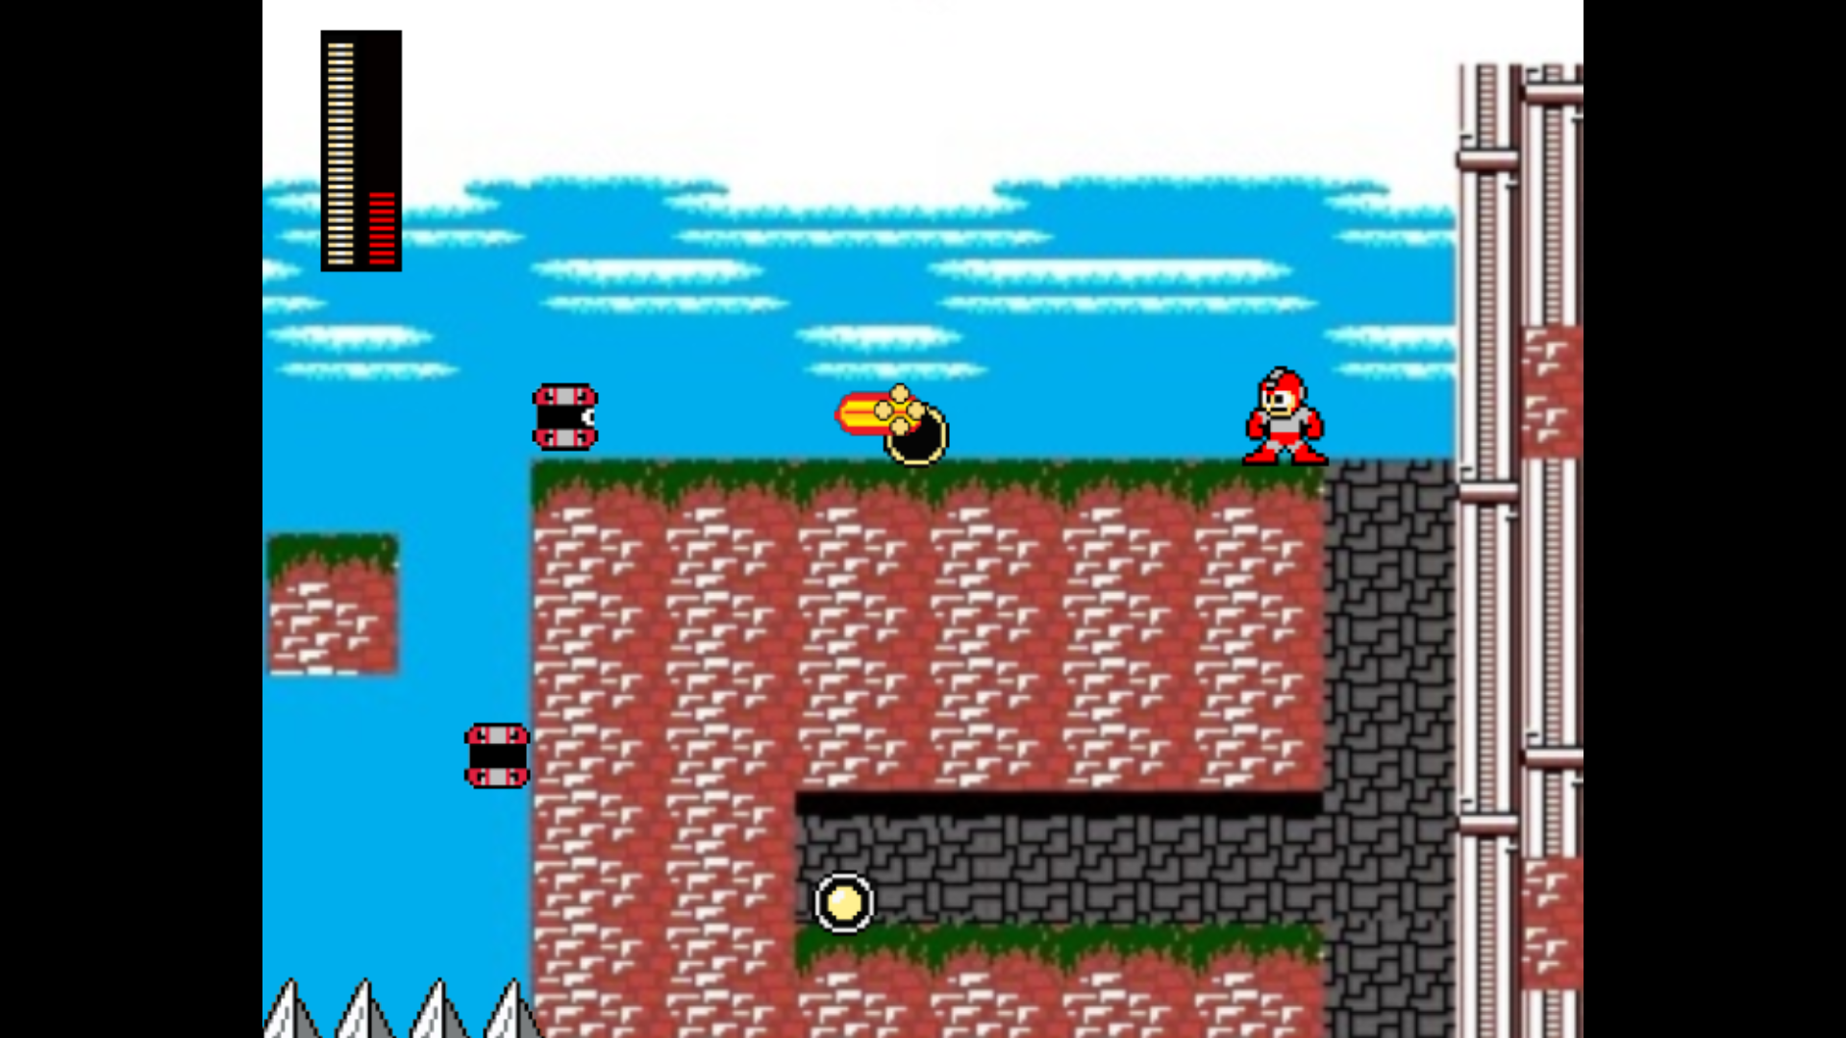

Megaman fights for his life against the evil Dr. Thornton

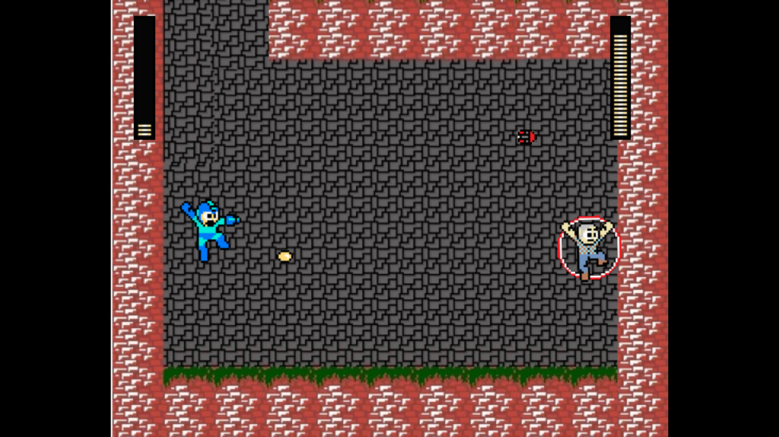

# SpaceE

## About

SpaceE was my first attempt at a click-and-drag puzzle game. The object of the game is to escape the room that you start off in, and figure out what is going on at the same time. Unfortunately, this game has suffered the most from GameMaker updates, and would need to be recoded heavily to be at 100% again. This game is the sequel to Before Death, and you play as a character named Dr. Newman. Newman, a father, was in a traffic accident with his young son, who was killed in the crash. He refuses to see that truth, and the point of the game is to make him come to terms with his loss. In the prequel, Before Death, the player actually controls the son right before this game’s fatal accident.

## How to run the game

To run SpaceE, open the containing folder “SpaceE game,” and locate then open the GameMaker file named “SpaceE – Epacse.project.” Once the folder is open, press the small green play button in the upper right hand corner of the GameMaker software.

## Contols

SpaceE is a point-and-click game, so the mouse is the only control option.

Left click on objects to collect the object.

Left click and hold to drag an object out of inventory and drop it onto a corresponding area in the level to activate the object.

Right click the object once to enlarge and view it, right click it again to shrink it.

## Screenshots

The opening room…lovely view

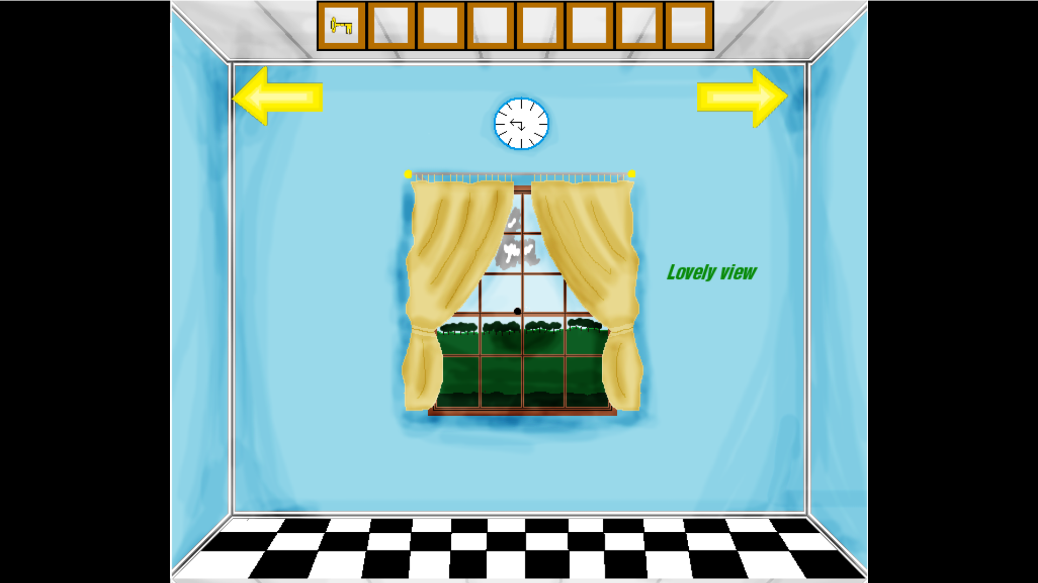

Enlarging an item so it can be easily viewed

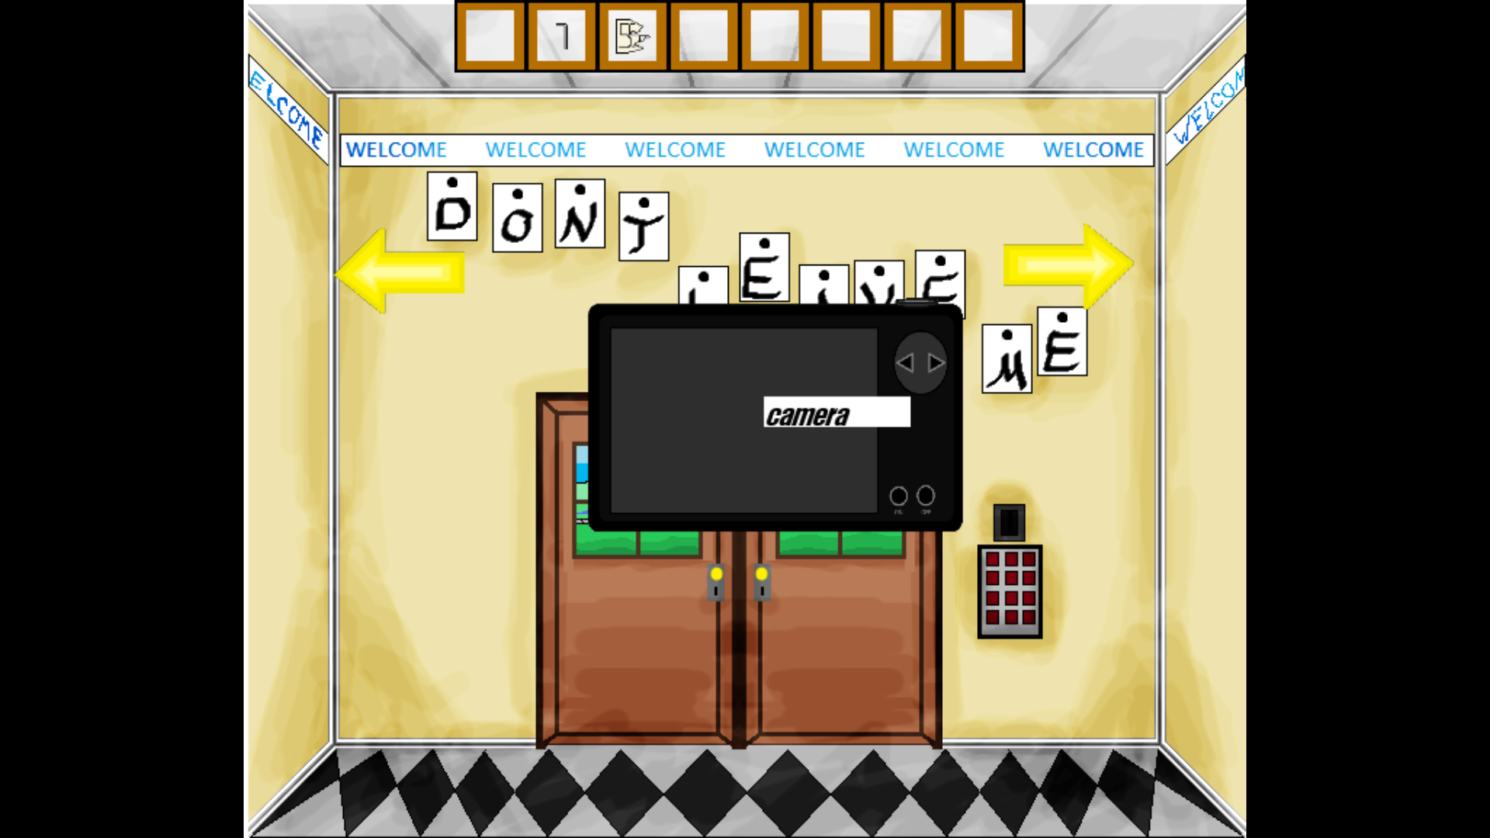

A bit of exposition for the player

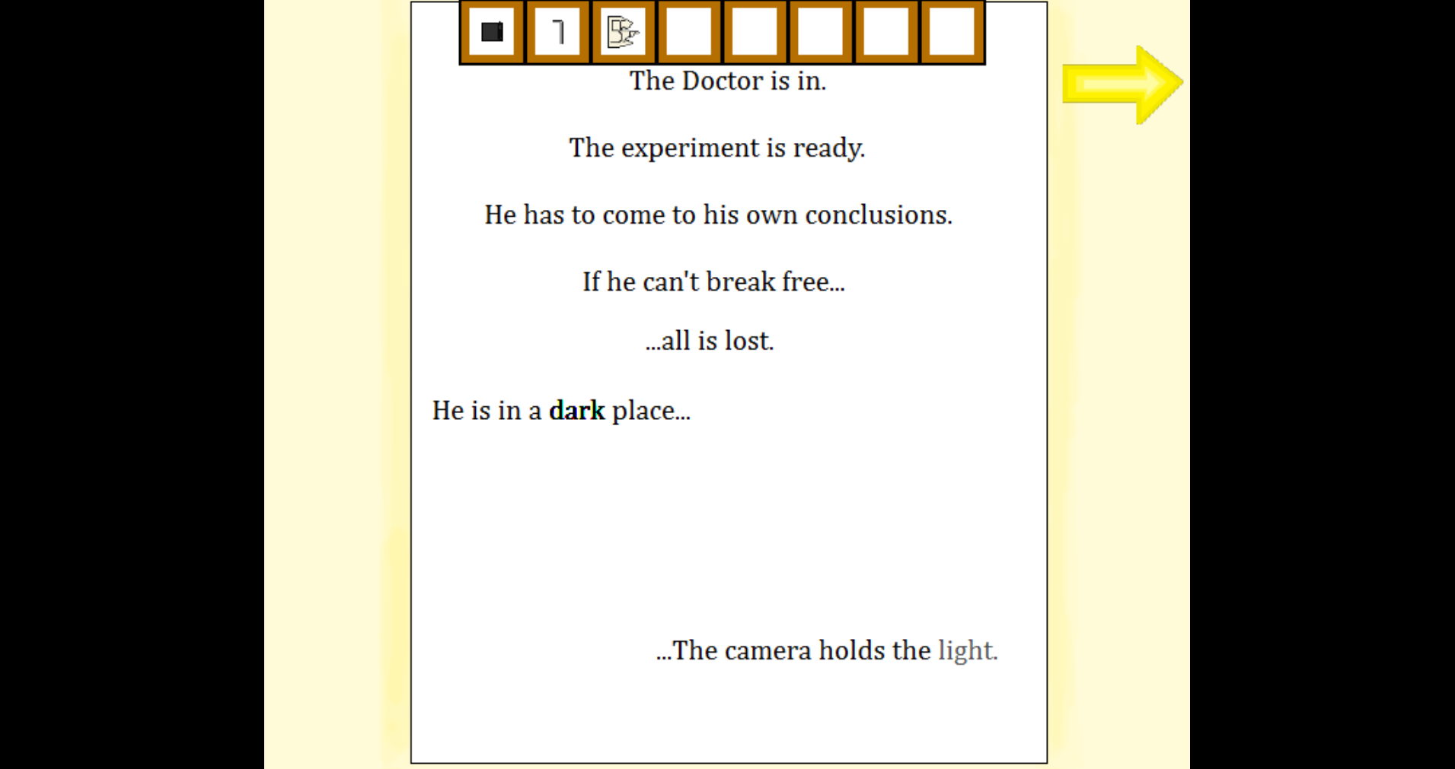

Hiding in a supply closet

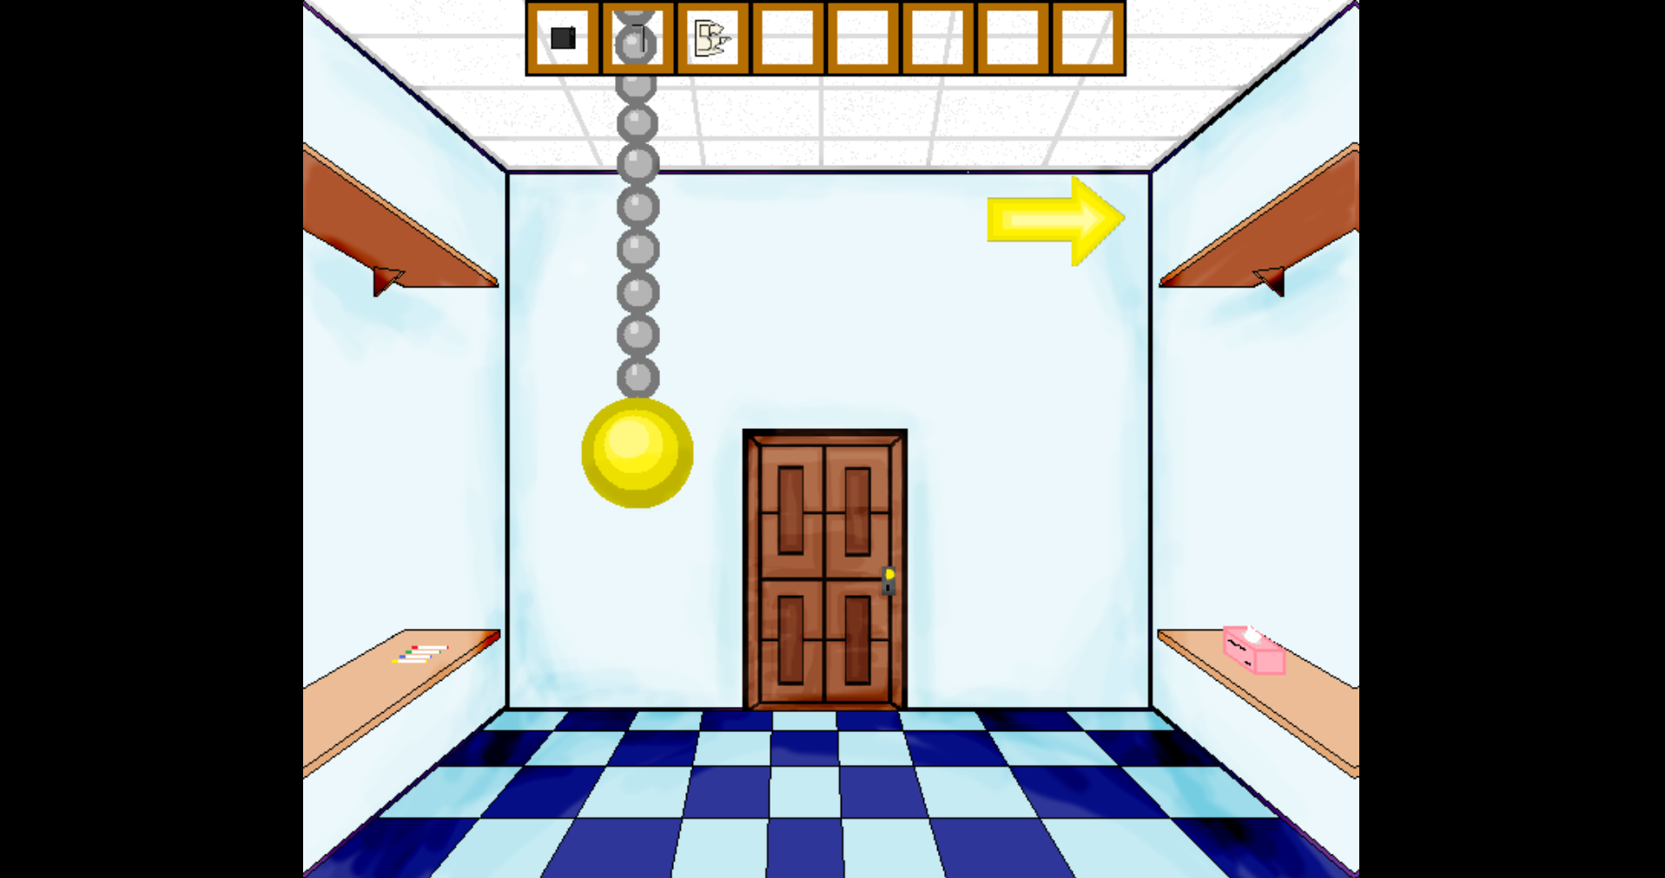

# GameJam Game

## About

This game was created in 48 hours for a game jam hosted by the CDC in Atlanta, Georgia. The game was meant to convey the dangers of texting and driving, and how you can suffer for your actions well after they happen. We ran out of time, but the game was meant to show that the player was reliving the deaths of a bus full of children that he had ran off the road while texting. This game suffers very little from updates to GameMaker, but it still has some odd kinks after so many updates. Everything for this game was created, from the music to the artwork, in less than 2 days.

## How to run the game

To run this game, open the folder named “GameJam game” and run the “GameJameCombine.project” file. Once GameMaker is open, play the game by pressing the small green play arrow in the upper left hand corner.

## Controls

Left/right arrow keys to move

Up arrow to jump

Enter key to attack

## Screenshots

Final boss battle

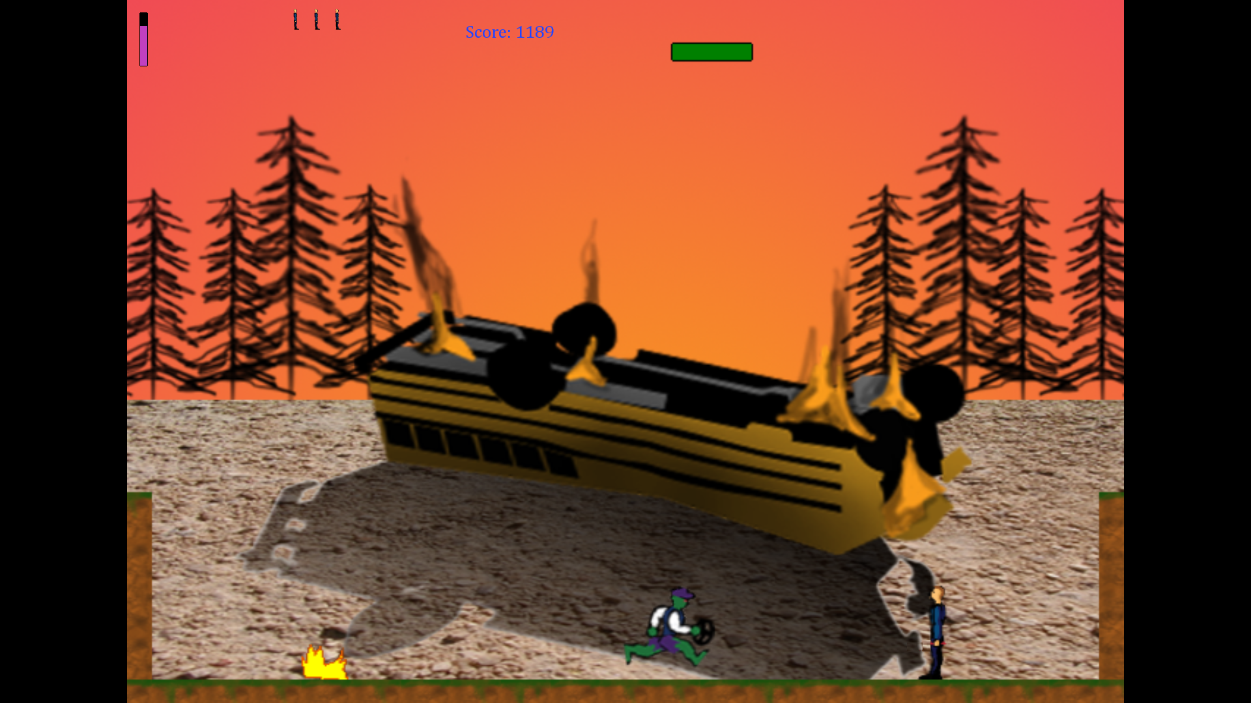

Part of the opening cutscene

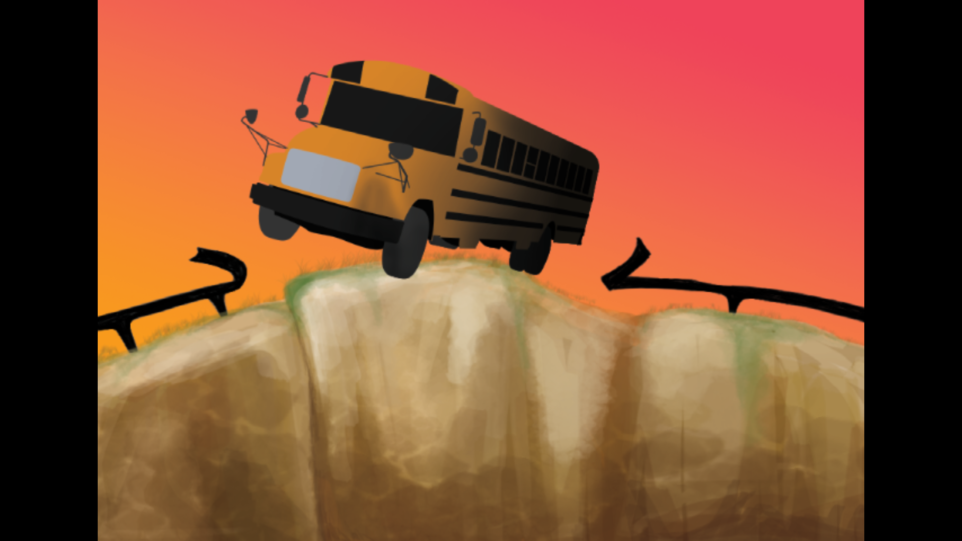

Fighting off the zombie horde

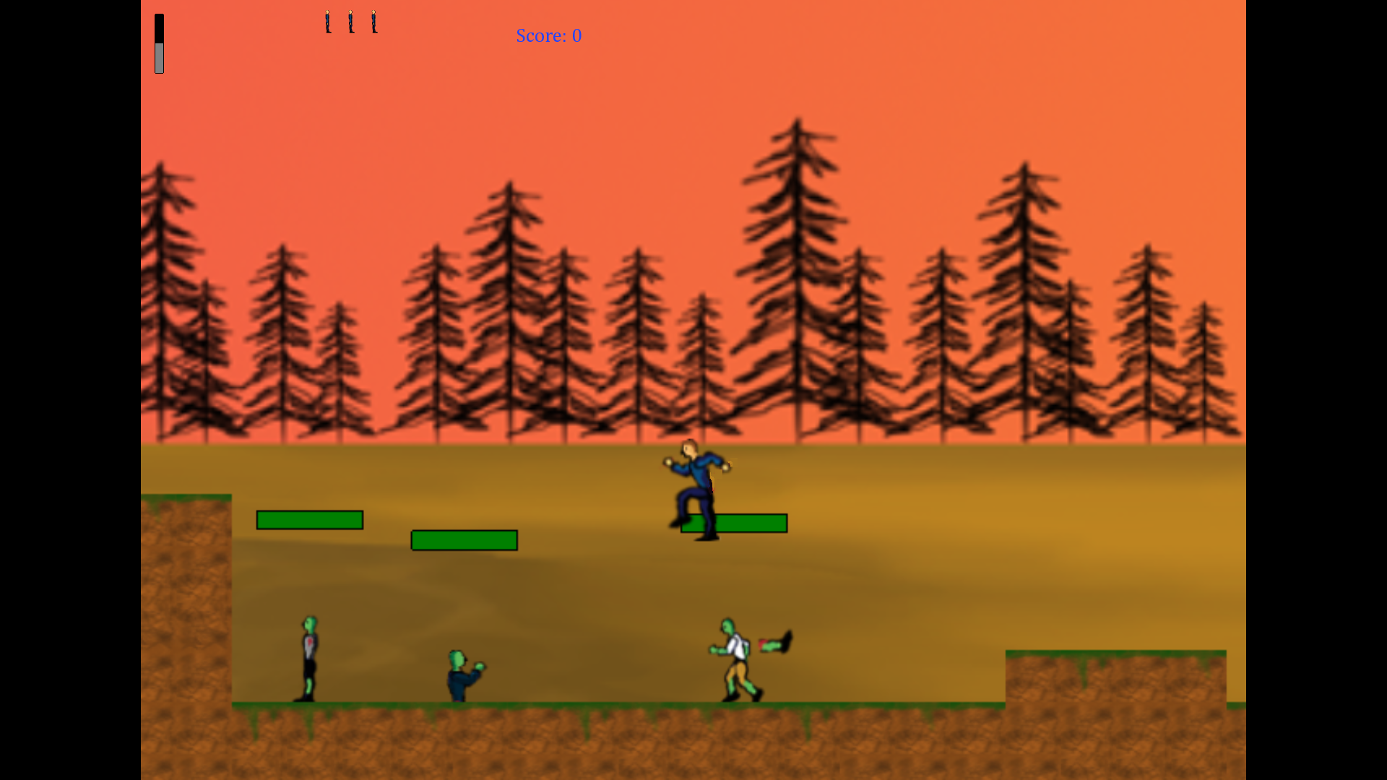

# Blender Works

## Lighthouse Island

This was an assignment where I had to create a lighthouse on an island. I took the time to create a light that rotated around, and water that moved to simulate tidal movements. I created all of the objects, including the island, lighthouse, and bridge. The short video included in the file is a full rotation of the lighthouse’s light.

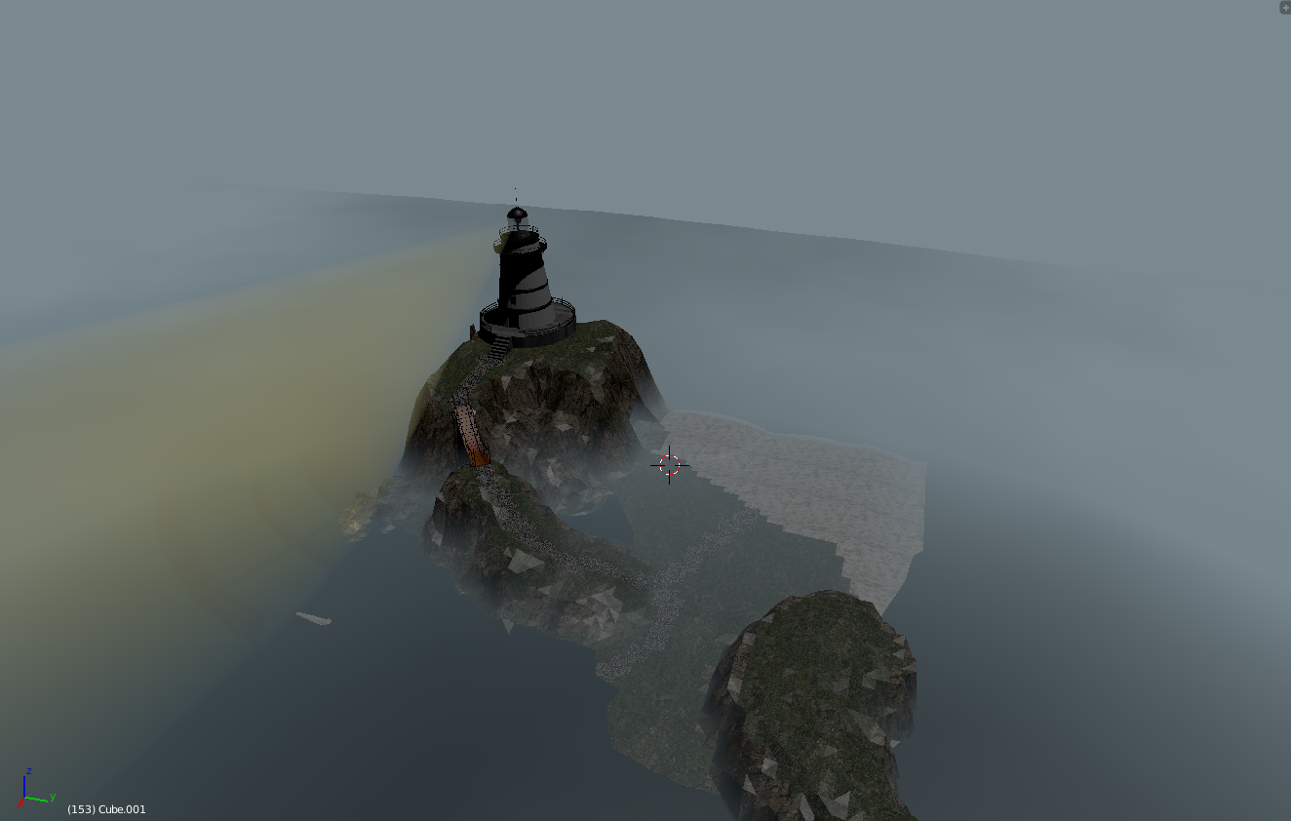

## Little Town

I somewhat modeled this town in the ‘old west’ style that you would see in a movie. It was the first time that I had made anything larger than a person within blender, and is more detailed than it first appears. The bar has little stools in it and a spotlight on its billboard, for example. This was mostly an experiment in creating buildings with different shapes and textures.

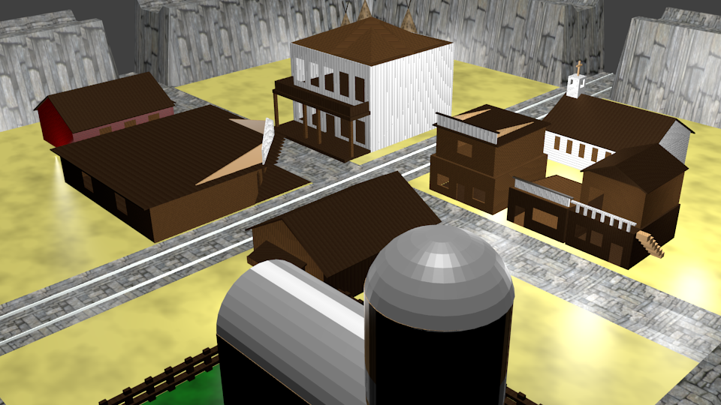

## Opening Room

This is the opening room and the cutscene room for my game, “Before Death”. This room was modeled after the artwork of the earlier game, “SpaceE”. I had to create this room from four different 2D images, and I could only make slight changes in order for it to retain its original look. Overall, it manages to retain most of what makes it unique in this 3D remake.

